LOCAL AREA NETWORK (LAN)

INNOVATION PROJECT FOR KALOLENI LAW COURT



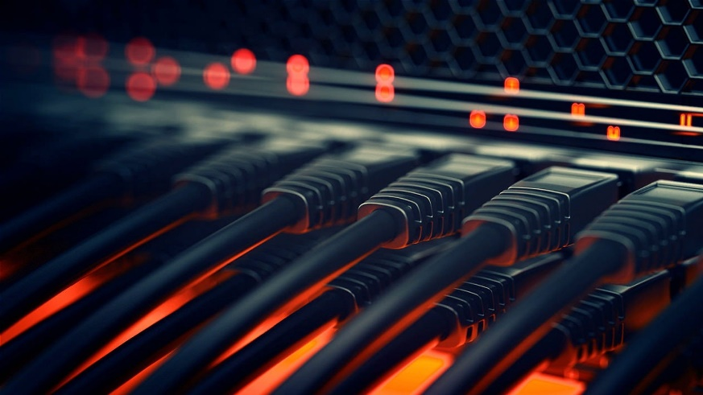

Background of the Problem

This innovation project was started so as to improve working conditions by mitigating specific problems experienced at Kaloleni Law Court. These problems include:

1. Shortage of Computers: There being a total of 4 computers at the registry to be shared amongst 12 staff members, completing daily duties is difficult especially when one has urgent matters to attend to.
2. Resource Sharing: In most working environments, the resources shared include printers and scanners, but this project focused more on sharing files and documents from one computer to another so as to allow people to work from any computer in the registry.
3. Lack of Backups: There being a lot of sensitive data on these computers, it is recommended to have online backups for casual documents while maintaining local backups for sensitive data.

What is a Local Area Network?

A Local Area Network, or LAN for short, is a computer network that connects devices within an area such as a home, office, or a small group of buildings. LANs are commonly used to share resources such as printers, files, and applications among connected devices.

LANs typically use Ethernet cables or Wi-Fi to connect devices such as computers, printers, and servers. The network is managed by a central device called a switch or hub. This device acts as a communication point between devices and helps to manage the flow of data on the network.

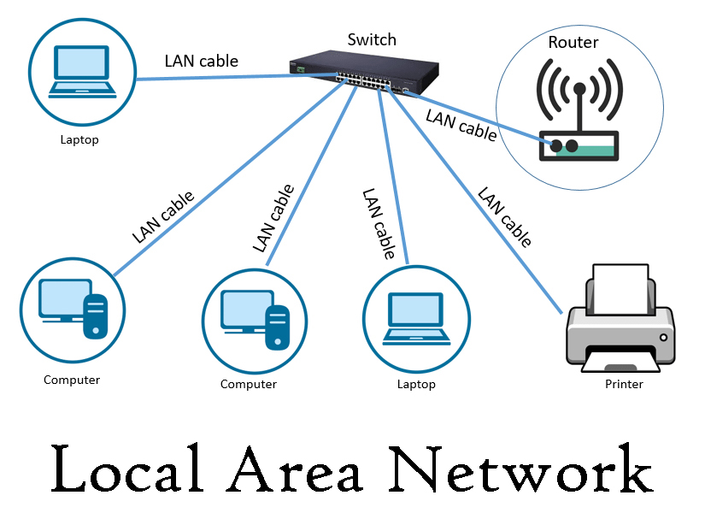

Local Area Network Image

Advantages of using LAN

There are several advantages of using a LAN, including:

1. Resource sharing: LANs allow devices such as printers, scanners, and documents to be shared among connected devices, reducing the need for each device to have its own dedicated resource.
2. Cost-effective: By eliminating the need for multiple devices, such as printers, setting up a Local Area Network is pocket friendly.
3. High-Speed Communication: LANs offer faster data transfer speeds due to the direct connectivity between computers
4. Centralized data management: This makes it easier to backup data, monitor network activity, and implement data security measures.
5. Flexible Work Environment: Personnel are able to share and work on documents saved in different computers in real-time.

Disadvantages of using LAN

Limited coverage area: A LAN is limited to a small geographical area

Dependence on central device: Devices such as a router or switch are crucial to the network. If this device fails, the entire network may be affected, leading to downtime and loss of productivity.

Complexity: Setting up and managing a LAN can be complex and require technical expertise, particularly for larger networks.

Security vulnerabilities: Despite being more secure than wide area networks, LANs are still vulnerable to cyber-attacks and other security threats. If not properly secured, a LAN can be compromised, leading to data theft, malware infections, and other security breaches.

How to set up LAN in windows

Setting up a LAN in Windows involves several steps:

1. Connect the computers: Connect the computers to the same network. This can be done using Ethernet cables, a wireless router, or a switch.

2. Configure network settings: On each computer, go to the Control Panel and select Network and Sharing Center. From there, select Change adapter settings and right-click on the Ethernet or Wi-Fi connection that you are using to connect to the LAN. Select Properties and make sure that the settings are configured for automatic IP address assignment (DHCP).

3. Set up a network name: On one of the computers, go to Control Panel and select Network and Sharing Center. From there, select Set up a new connection or network and follow the prompts to set up a network name and select the type of network you want to create (work or home).

4. Share resources: On each computer, select the files or printers that you want to share. Right-click on the file or printer and select Properties. From there, select the Sharing tab and select the option to share the resource.

5. Access shared resources: On each computer, you should now be able to access the shared resources from other computers on the LAN. To do this, go to File Explorer and select Network. You should see the other computers and shared resources on the LAN.

By following these steps, you can set up a LAN in Windows and share resources among multiple computers on the network.